**ONLINE DEVICE CONTROLLER**

**ABSTRACT**

The ‘Online Device Controller (ODC) is a multi-channel hardware administration system that has been developed to enable the control of equipments and appliances from any part of the world, through the Internet. The concept of ODC is a relatively new one, and makes use of Common Gateway interface (CGI), a very powerful technique that was hitherto used solely for e-mail, database access and other ‘soft’ purposes involving dynamic web page content. But, through this project we have made an attempt to bring a very powerful but often unknown and underutilised aspect of CGI; the same technique used to manipulate our e-mail accounts can equally well be applied to access the parallel port of the web server, and control hardware through it.

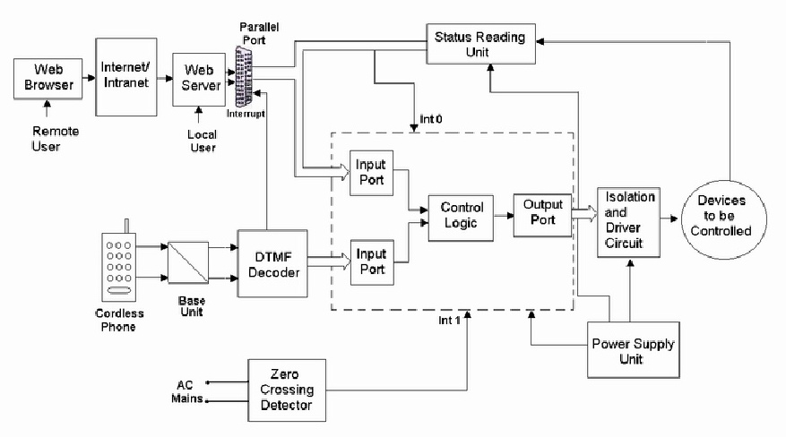

**Block diagram**

Our project, the ‘Online Device Controller’ allows a remote user to login to the Web server and control the devices connected to the server. Also provided is the feature to control the same devices locally, through a Cordless Telephone. The present product offers the facility to remotely control an ON/OFF device and an Intensity Variable load, through the Internet, and locally through a Cordless telephone and is a product of paramount significance in office, industrial and household applications.